In This Lab, we will create VM in Private add Public Subnets of our new VPC

And we will also check connectivity between them

Go to VM Instance page, create New VM and make sure to select region same as of subnet

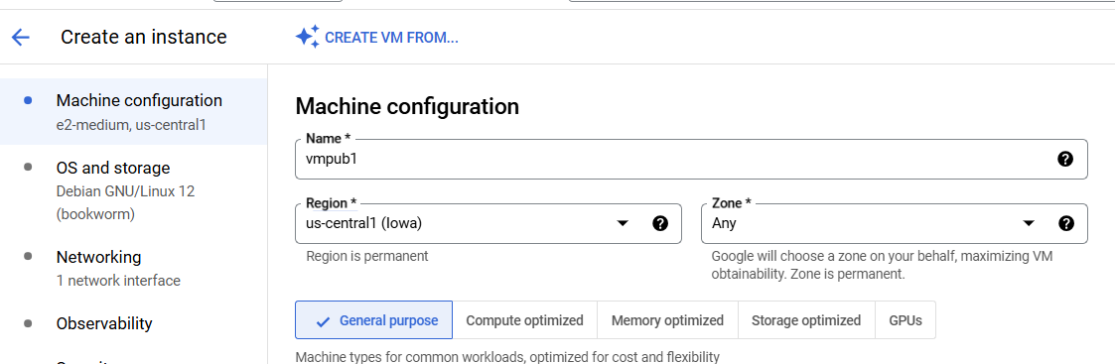

Keep all options same as of VM lab, only make changes to the Networking options

Go to Networking tab and expand Network Interfaces option and **do not check the Firewall rules** to allow traffic

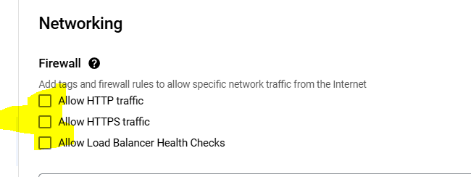

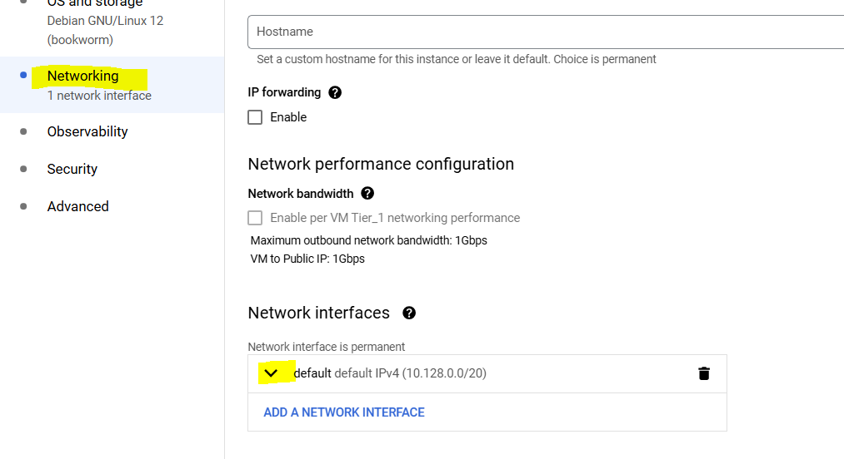

Select myvpc and pub subnet, keep rest default

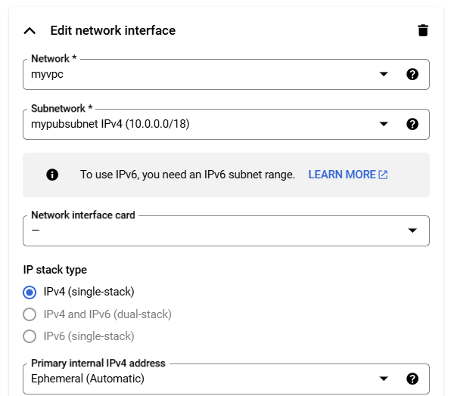

Now create a VM in private subnet, for this follow same steps as above, only give VM name as prvvm and in networking select private subnet

